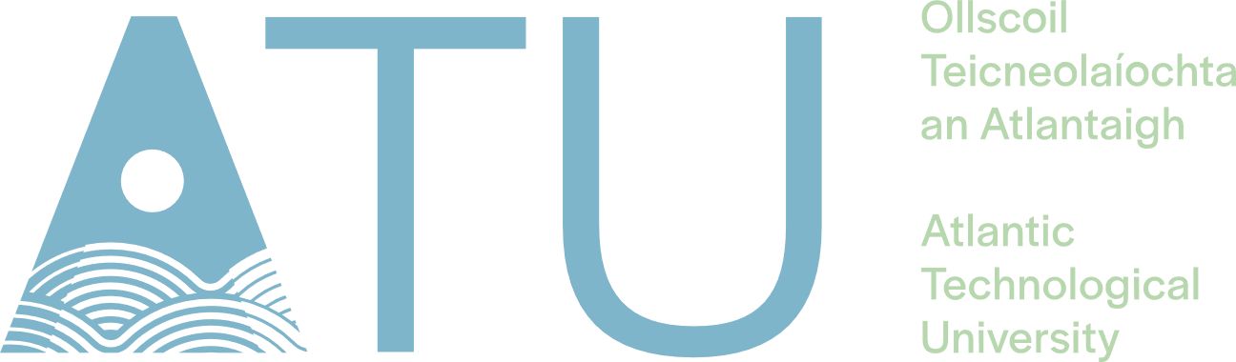

**“The Breathalyser Connection”**

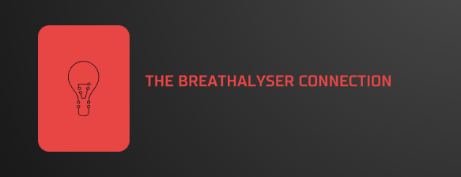

**Project Engineering**

**Project Proposal**

**Lorcan Stakem**

**BEng (Hons) in Software & Electronic Engineering**

Supervised by

Atlantic Technological University

2022/2023

# Project Description

In Ireland, driving while intoxicated is a serious offense that is increasing in frequency and contributes significantly to crashes on roads that result in fatalities and significant injuries. This proposed project aims to discourage users from driving after drinking, which will lower the number of accidents caused by driving under the influence of alcohol. The main components of the proposed system are an ESP32 microcontroller and an alcohol detection sensor (MQ-3) which will detect from the user’s breath If they are above the Irish legal threshold of 50 milligrams (mg) per 100ml of blood (equivalent to drinking less than a pint) and discourages drivers from entering their vehicle.

A green and red LED are implemented to indicate if a test was successful or unsuccessful and used to illustrate the presence of alcohol detected by indicating a glow on the LEDs respectively. An LCD display to show your BAC (Blood alcohol content) level and a piezo buzzer for indicating a presence of a high alcohol level If detected. An ESP32 microcontroller handles each of these components. All the parts are interfaced and programmed to operate the project in synchronization. I wish to make the project battery compatible by using voltage from a lithium polymer rechargeable battery which will power the ESP32 microcontroller board.

React Native will be used as the framework for the front-end development, and Expo will likely be used for the prototyping and graphical user interface. This will create a smartphone application (or "app") that is compatible with the two most popular mobile operating systems in Apple's iOS and Google's Android. My primary programming languages for this project will be JavaScript using Node.js and C/C++ using the Arduino IDE.

The integration of the hardware in calibrating with the development of the mobile app using React Native, in my opinion, will be the project's main challenge. I've never developed a mobile app before, but I want to ensure that the results of the alcohol detection test are as accurate as possible, therefore I want to make it as specific and interesting using Node.js when I display the data for the breathalyser test results.

If I have enough time, I'd like to be able to create my own personalised design for the project which I will construct myself. Furthermore, I'd like to shorten the period the battery is left sitting idle so additionally, I'd like to add an on/off switch that can be turned off while the project is not in use.

# Architecture Diagram

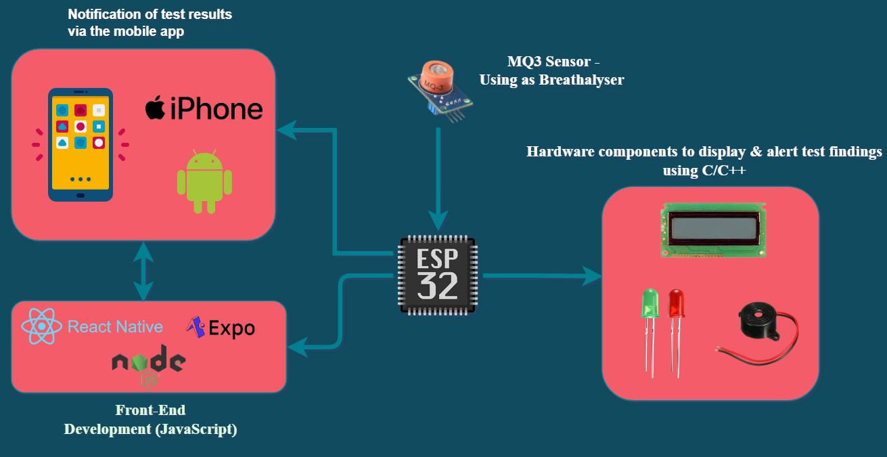

# Timeline of deliverables

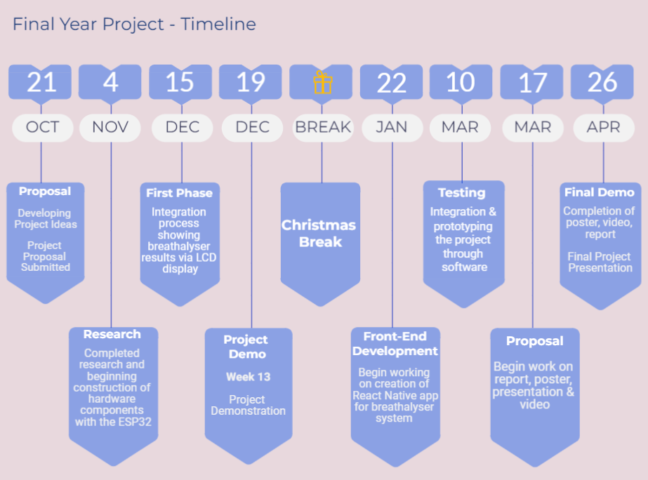

# Technologies Used

